CALL CENTER DATA ANALYSIS

NAME: Sayantan Malladeb

CONTACT: [sm103@illinois.edu](mailto:sm103@illinois.edu)

*Insightful questions and information regarding data analysis:*

1. What is the shape of our data?

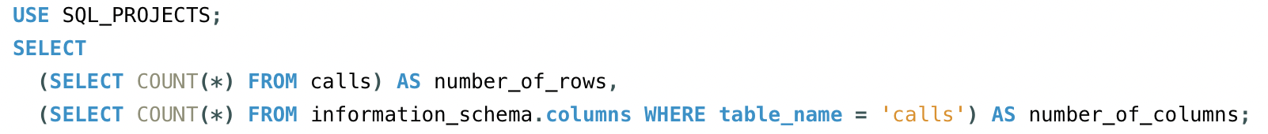

RESULT:

1. What are the distinct values of the columns sentiment, reason, channel, response_time and call_center?

RESULT:

1. What are the counts and percentages of each of the distinct values from the above 5 columns?

RESULT:

1. What are the TOP 10 and BOTTOM 10 states by the number of calls received?

RESULT:

1. Which days are the busiest?



RESULT:

1. **Aggregate questions**

*MINIMUM, MAXIMUM and AVERAGE customer satisfaction scores:*

*TIME RANGE of our data:*

*MINIMUM, MAXIMUM and AVERAGE call durations:*

*Retrieve the records of calls that took 45 MINUTES OR MORE and SENTIMENT was NEGATIVE OR VERY NEGATIVE:  
*

*Primary reasons for the calls above:*

*RESPONSE TIME PERFORMANCE of call centers:  
*

*AVERAGE CALL DURATIONS by call center:  
*

*AVERAGE CALL DURATIONS by channel*

*:*

1. What is the preferred channel of communication for the customers?  
   A close-up of a white background

   Description automatically generated

RESULT:

1. What is the average customer satisfaction score by state?

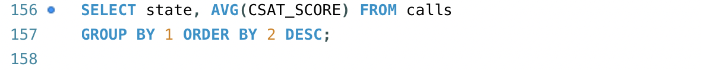

RESULT:

1. What are the top 10 and bottom 10 busiest days in our data?

RESULT:

1. **Sentiment analysis questions**

*COUNT OF SENTIMENT BY STATE:*

*AVERAGE CALL DURATION BY SENTIMENT:*

*AVERAGE CUSTOMER SATISFACTION SCORE BY STATE WHERE SENTIMENT IS VERY POSITIVE OR VERY NEGATIVE:*

*AVERAGE CUSTOMER SATISFACTION SCORE BY SENTIMENT:*

